APPLICATION FOR CARE AT EVOLVE CHIROPRACTIC

Whom may we thank for referring you to this office? ______________________________________
Today’s Date: __________________

PATIENT DEMOGRAPHICS

Name: _______________________________________________ Birth Date: _____-_____-_____ Age: _______ □ Male □ Female

Address: _____________________________________________ City: _____________________________ State: _____ Zip: ____________

Home Phone: _________________________________________ Work Phone: _________________________________________________

Cell Phone: ___________________________________________ Cell Carrier: __________________________________________________

E-mail Address: _____________________________________ Preferred Method of Contact: □ Email □ Home Phone □ Cell Phone

Marital Status: ◻ Single ◻ Married ◻ Divorced ◻ Widowed Do you have Insurance: ◻ Yes ◻ No

Social Security #: ______________________________________ Driver’s License #: _____________________________________________

Employer: ___________________________________________ Occupation: __________________________________________________

Spouse’s Name _______________________________________ Spouse’s Employer: ____________________________________________

Number of children, names, and ages: _________________________________________________________________________________

Are you Pregnant? □No □ Yes If yes, due date: _____________________ Who is your OB(s)? _________________________________

Where are you delivering? __________________________________________________________________________________________

May we contact your provider if needed? □ Yes □ No

Name & Number of Emergency Contact: _________________________________________Relationship: ___________________________

HISTORY of COMPLAINT
Please identify the condition(s) that brought you to this office:
Primary: _________________________________________________________________________________________________________
Secondary: _______________________________________________________________________________________________________

Third: ___________________________________________________________________________________________________________

Fourth: __________________________________________________________________________________________________________

On a scale of 1 to 10 with 10 being the worst pain and zero being no pain, rate your above complaints by circling the number:
Primary or chief complaint is: 0 – 1 – 2 – 3 – 4 – 5 – 6 – 7 – 8 – 9 – 10
Second complaint is: 0 – 1 – 2 – 3 – 4 – 5 – 6 – 7 – 8 – 9 – 10
Third complaint is: 0 – 1 – 2 – 3 – 4 – 5 – 6 – 7 – 8 – 9 – 10
Fourth complaint is: 0 – 1 – 2 – 3 – 4 – 5 – 6 – 7 – 8 – 9 – 10

Is your problem the result of ANY type of injury/accident? □ No □ Yes Type of Accident: □ Auto □ Home □ Other

If yes, please explain: ______________________________________________________________________________________________

When did the problem(s) begin? ____________________ When is the problem at its worst? □ AM □ PM □ mid-day □ late PM

How long does it last? □ It is constant OR □ I experience it on and off during the day OR □ It comes and goes throughout the week

Have you suffered from this before? ◻ No ◻ Yes If yes, how many times? ____________ When was the last episode? _______________

Have you tried other treatments: □ No □ Yes If yes, please state what type of treatment: _____________________________________

Who provided it: ______________________________________ How long ago? _______________________________________________

Were the results □ Favorable □ Unfavorable → please explain. ____________________________________________________________

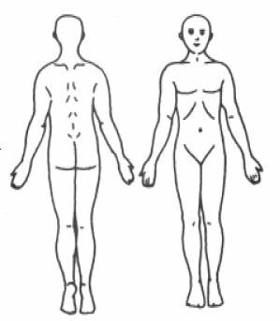
Name of Previous Chiropractor: _______________________________________ ◻ N/A

PLEASE MARK the areas on the Diagram with the following letters to describe your symptoms:
R = Radiating B = Burning D = Dull A = Aching N = Numbness S = Sharp/Stabbing T = Tingling

What relieves your symptoms? ____________________________________________________

What makes your symptoms feel worse? ____________________________________________

Identify any other injury(s) to your spine, minor or major, that the doctor should know about:
_________________________________________________________________________________________________________________
_________________________________________________________________________________________________________________

PAST HISTORY

If you have ever been diagnosed with any of the following conditions, please indicate with a P for in the Past, C for Currently have or N for Never have had:
___ Broken Bone ___Dislocations ___ Tumors ___Rheumatoid Arthritis ___Disability ___Cancer
___ Heart Attack ___Osteo Arthritis ___ Diabetes ___Cerebral Vascular/Stroke ___ Other serious conditions: _________

PLEASE identify ALL PAST and any CURRENT conditions you feel may be contributing to your present problem:
HOW LONG AGO TYPE OF CARE RECEIVED BY WHOM
INJURIES →
SURGERIES →
CHILDHOOD DISEASES →
ADULT DISEASES →

SOCIAL HISTORY

- Smoking: ◻cigars ◻ pipe ◻ cigarettes How often? ◻ Daily ◻ Weekends ◻ Occasionally ◻ Never
- Alcoholic Beverage: consumption occurs ◻ Daily ◻ Weekends ◻ Occasionally ◻ Never
- Recreational Drug use: ◻ Daily ◻ Weekends ◻ Occasionally ◻ Never

FAMILY HISTORY:

- Does anyone in your family suffer with the same condition(s)? ◻ No ◻ Yes
If yes whom: ◻ grandmother ◻ grandfather ◻ mother ◻ father ◻ sister(s) ◻ brother(s) ◻ son(s) ◻ daughter(s) Have they ever been treated for their condition? ◻ No ◻ Yes ◻ I don’t know

- Any other hereditary conditions the doctor should be aware of? ◻ No ◻ Yes: ___________________________________

List Prescription & Non-Prescription drugs you take: _________________________________________________________
_____________________________________________________________________________________________________
_____________________________________________________________________________________________________

ACTIVITIES OF LIFE
Please identify how your current condition is affecting your ability to carry out activities that are routinely part of your life:

ACTIVITIES: |  | EFFECT:
Carry Children/Groceries | □ No Effect | □ Painful (can do) | □ Painful (limits) | □ Unable to Perform
Sit to Stand | □ No Effect | □ Painful (can do) | □ Painful (limits) | □ Unable to Perform
Climb Stairs | □ No Effect | □ Painful (can do) | □ Painful (limits) | □ Unable to Perform
Extended Computer Use | □ No Effect | □ Painful (can do) | □ Painful (limits) | □ Unable to Perform
Lift Children/Groceries | □ No Effect | □ Painful (can do) | □ Painful (limits) | □ Unable to Perform
Read/Concentrate | □ No Effect | □ Painful (can do) | □ Painful (limits) | □ Unable to Perform
Getting Dressed | □ No Effect | □ Painful (can do) | □ Painful (limits) | □ Unable to Perform
Shaving | □ No Effect | □ Painful (can do) | □ Painful (limits) | □ Unable to Perform
Sexual Activities | □ No Effect | □ Painful (can do) | □ Painful (limits) | □ Unable to Perform
Sleep | □ No Effect | □ Painful (can do) | □ Painful (limits) | □ Unable to Perform
Static Sitting | □ No Effect | □ Painful (can do) | □ Painful (limits) | □ Unable to Perform
Static Standing | □ No Effect | □ Painful (can do) | □ Painful (limits) | □ Unable to Perform
Yard work | □ No Effect | □ Painful (can do) | □ Painful (limits) | □ Unable to Perform
Walking | □ No Effect | □ Painful (can do) | □ Painful (limits) | □ Unable to Perform
Washing/Bathing | □ No Effect | □ Painful (can do) | □ Painful (limits) | □ Unable to Perform
Driving | □ No Effect | □ Painful (can do) | □ Painful (limits) | □ Unable to Perform
Other: _____________ | □ No Effect | □ Painful (can do) | □ Painful (limits) | □ Unable to Perform

Please put a for in the Past, circle the word for Currently have, or leave blank for Never
___ Headache ___ Pregnant (Now) ___ Dizziness | ___ Prostate Problems ___ Ulcers
___ Neck Pain ___ Frequent Colds/Flu ___ Loss of Balance | ___ Impotence/Sexual Dysfun. ___ Heartburn
___ Jaw Pain, TMJ ___ Convulsions/Epilepsy ___ Fainting | ___ Digestive Problems | ___ Heart Problem
___ Shoulder Pain ___ Tremors ___ Double Vision | ___ Colon Trouble | ___ High Blood Pressure
___ Upper Back Pain ___ Chest Pain ___ Blurred Vision | ___ Diarrhea/Constipation | ___ Low Blood Pressure
___ Mid Back Pain ___ Pain w/Cough/Sneeze ___ Ringing in Ears | ___ Menopausal Problems | ___ Asthma
___ Low Back Pain ___ Foot or Knee Problems ___ Hearing Loss | ___ Menstrual Problem | ___ Difficulty Breathing
___ Hip Pain ___ Sinus/Drainage Problem ___ Depression | ___ PMS | ___ Lung Problems
___ Back Curvature ___ Swollen/Painful Joints ___ Irritable | ___ Bed Wetting | ___ Kidney Trouble
___ Scoliosis ___ Skin Problems ___ Mood Changes | ___ Learning Disability | ___ Gall Bladder Trouble
___ Numb/Tingling arms, hands, fingers ___ ADD/ADHD | ___ Eating Disorder | ___ Liver Trouble
___ Numb/Tingling legs, feet, toes ___ Allergies | ___ Trouble Sleeping | ___ Hepatitis (A,B,C)

I hereby authorize payment to be made directly to Evolve Chiropractic, for all benefits which may be payable under a healthcare plan or from any other collateral sources. I authorize utilization of this application or copies thereof for the purpose of processing claims and effecting payments, and further acknowledge that this assignment of benefits does not in any way relieve me of payment liability and that I will remain financially responsible to Evolve Chiropractic for any and all services I receive at this office.

_____________________________________ _____ - _____ - _____
Patient or Authorized Person’s Signature Date Completed

_____________________________________ _____ - _____ - _____
Doctor’s Signature

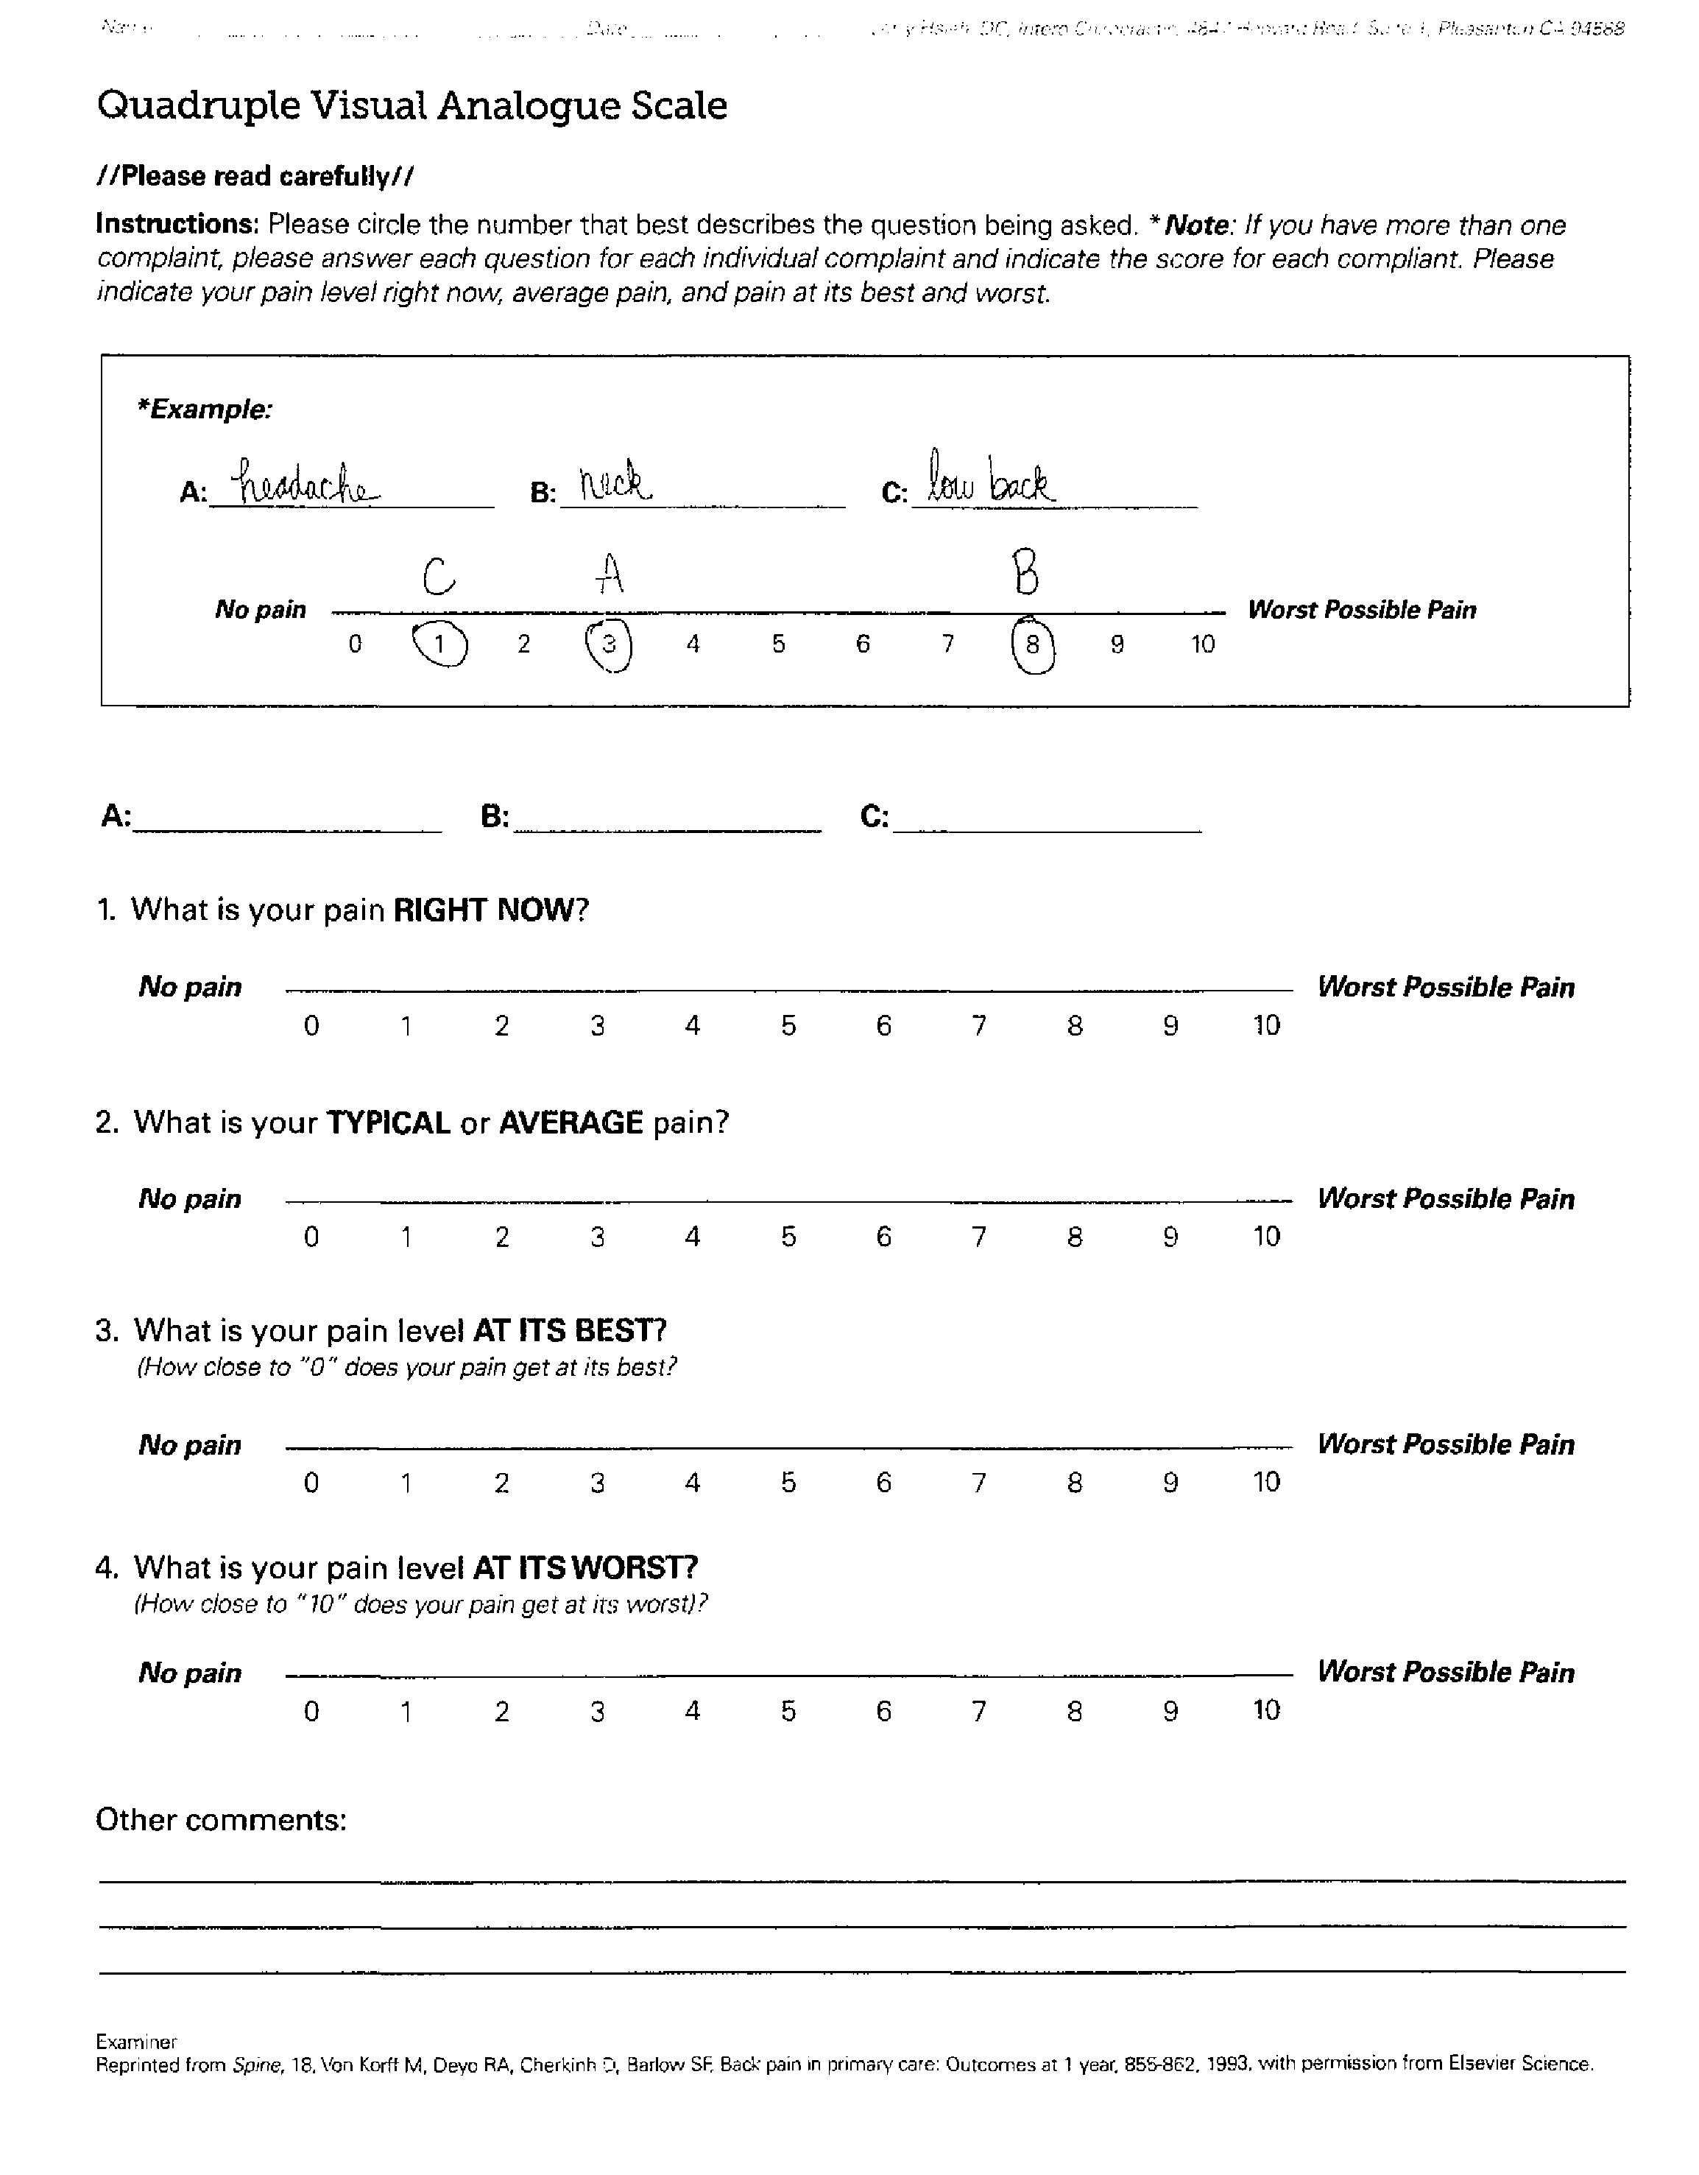

Informed Consent

REGARDING: Chiropractic Adjustments, Modalities, and Therapeutic Procedures:

I have been advised that chiropractic care, like all forms of health care, holds certain risks. While the risk are most often very minimal, in rare cases, complications such as sprain/strain injuries, irritation of a disc condition, and although rare, minor fractures, and possible stroke, which occurs at a rate between one instance per one million to one per two million, have been associated with chiropractic adjustments.

Treatment objectives as well as the risks associated with chiropractic adjustments and, all other procedures provided at Evolve Chiropractic have been explained to me to my satisfaction and I have conveyed my understanding of both to the doctor. After careful consideration, I do hereby consent to treatment by any means, method, and or techniques, the doctor deems necessary to treat my condition at any time throughout the entire clinical course of my care.
_________________________________________ ____/____/____ Witness Initials
Patient or Authorized Person’s Signature Date

REGARDING: X-rays/Imaging Studies
By my signature below I am acknowledging that the doctor and or a member of the staff has discussed with me the hazardous effects of ionization to an unborn child, and I have conveyed my understanding of the risks associated with exposure to x-rays. After careful consideration I therefore, do hereby consent to have the diagnostic x-ray examination the doctor has deemed necessary in my case.
_________________________________________ ____/____/____ Witness Initials
Patient or Authorized Person’s Signature Date

FEMALES ONLY → please read carefully and check the boxes, include the appropriate date, then sign below if you understand and have no further questions, otherwise see our receptionist for further explanation.

- The first day of my last menstrual cycle was on ____-____-____ (Date)
- I have been provided a full explanation of when I am most likely to become pregnant, and to the best of my knowledge, I am not pregnant.
_________________________________________ ____/____/____ Witness Initials
Patient or Authorized Person’s Signature Date

EVOLVE CHIROPRACTIC NOTICE OF PRIVACY PRACTICE
This office is required to notify you in writing, that by law, we must maintain the privacy and confidentiality of your Personal Health Information. In addition, we must provide you with written notice concerning your rights to gain access to your health information, and the potential circumstances under which, by law, or as dictated by our office policy, we are permitted to disclose information about you to a third party without your authorization. Below is a brief summary of these circumstances. If you would like a more detailed explanation, one will be provided to you. In addition, you will find we have placed several copies in report folders labeled ‘HIPAA’ on tables in the reception. Once you have read this notice, please sign the last page, and return only the signature page (page 2) to our front desk receptionist. Keep this page for your records.

PERMITTED DISCLOSURES:
- Treatment purposes - discussion with other health care providers involved in your care.
- Inadvertent disclosures - open treating area mean open discussion. If you need to speak privately to the doctor, please let our staff know so we can place you in a private consultation room.
- For payment purposes - to obtain payment from your insurance company or any other collateral source.
- For workers compensation purposes - to process a claim or aid in investigation.
- Emergency - in the event of a medical emergency we may notify a family member.
- For Public health and safety - in order to prevent or lessen a serious or eminent threat to the health or safety of a person or general public.
- To Government agencies or Law enforcement - to identify or locate a suspect, fugitive, material witness or missing person.
- For military, national security, prisoner and government benefits purposes.
- Deceased persons - discussion with coroners and medical examiners in the event of a patient’s death.
- Telephone calls or emails and appointment reminders - we may call your home and leave messages regarding a missed appointment or apprize you of changes in practice hours or upcoming events.
- Change of ownership- in the event this practice is sold, the new owners would have access to your PHI.

YOUR RIGHTS:
- To receive an accounting of disclosures.
- To receive a paper copy of the comprehensive “Detail” Privacy Notice.
- To request mailings to an address different than residence.
- To request Restrictions on certain uses and disclosures and with whom we release information to, although we are not required to comply. If, however, we agree, the restriction will be in place until written notice of your intent to remove the restriction.
- To inspect your records and receive one copy of your records at no charge, with notice in advance.
- To request amendments to information. However, like restrictions, we are not required to agree to them.
- To obtain one copy of your records at no charge, when timely notice is provided (72 hours). X-rays are original records and you are therefore not entitled to them. If you would like us to outsource them to an imaging center, to have copies made, we will be happy to accommodate you. However, you will be responsible for this cost.

COMPLAINTS:
If you wish to make a formal complaint about how we handle your health information, please call Dr. Stefanie Ascher at (607)-768-9127. If she is unavailable, you may make an appointment with our receptionist to see her within 72 hours or 3 working days. If you are still not satisfied with the manner in which this office handles your complaint, you can submit a formal complaint to:

DHHS, Office of Civil Rights
200 Independence Ave. SW Room 509F HHH Building
Washington DC 20201

EVOLVE CHIROPRACTIC NOTICE REGARDING YOUR RIGHT TO PRIVACY continued…

I have received a copy of EVOLVE CHIROPRACTIC Patient Privacy Notice. I understand my rights as well as the practice’s duty to protect my health information, and have conveyed my understanding of these rights and duties to the doctor. I further understand that this office reserves the right to amend this “Notice of Privacy Practice” at a time in the future and will make the new provisions effective for all information that it maintains past and present.

I am aware that a more comprehensive version of this “Notice” is available to me and several copies kept in the reception area. At this time, I do not have any questions regarding my rights or any of the information I have received.

Patient’s Name DOB _ HR# _________

Patient’s Signature Date __________

Witness __________________

Medical Information Release Form
(HIPAA Release Form)
Name: Date of Birth:
Release of Information:

[ ] I authorize the release of information including the diagnosis, records; examination rendered to me and claims information. This information may be released to:
[ ] Spouse ________________________________ [ ] Child(ren) ___________________

[ ] Other _________________________________ [ ] Information is not to be released to anyone.

This Release of Information will remain in effect until terminated by me in writing.

Messages:

Please call [ ] my home [ ] my work [ ] my mobile number:

If unable to reach me:
[ ] you may leave a detailed message [ ] please leave a message asking me to return your call
[ ]

The best time to reach me is (day) between (time)

Signed: ______________________ | Date: __________
Witness: _____________________ | Date: __________

